Human Biology –General Year 12 2018

Task 3 – Unit 3

**Assessment Type:** Test

**Task Weighting :** 7.5% **Name : Total: /42**

***MULTIPLE CHOICE SECTION [8 MARKS]***

1. 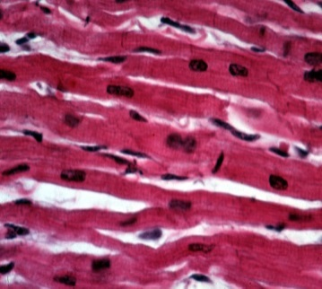A student examining a microscope slide of muscle tissue under the microscope saw the presence of striations and intercalated discs. The type of muscle he was looking at was:
2. Cardiac muscle
3. Skeletal muscle
4. Smooth muscle
5. Tendon
6. Which of the statement below is true of the image below?

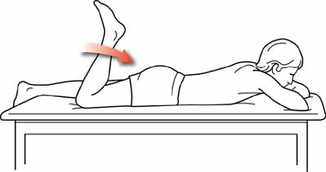

Hamstring

Quadriceps

1. To bring his foot towards his buttocks, the person must have contracted his quadriceps and relaxed his hamstrings
2. To bring his foot towards his buttocks, the person must have contracted his hamstrings and relaxed his quadriceps
3. To bring his foot towards his buttocks, the person must have contracted his quadriceps and also contracted his hamstrings
4. To bring his foot towards his buttocks, the person must have relaxed both his quadriceps and his hamstrings because neither of these muscles groups is involved in this action which is in fact performed by other leg muscles
5. Muscles are attached to bones by:  
   1. Cartilage
   2. Synovials
   3. Ligaments
   4. Tendons
6. Which of the following is the name for the synapse between a muscle and nerve cell?
   1. Synovials
   2. Neuromuscular Junction
   3. Muscular Synapse
   4. Sarcromere
7. Muscles always act:   
   1. Singly
   2. In pairs
   3. In threes
   4. Only when we think about them
8. Which of the following describes the structure of a skeletal muscle?
   1. Myofibril 🡪 actin and myosin🡪 myofilaments🡪 muscle fiber
   2. Actin and myosin🡪 microfilaments 🡪 myofibril🡪 muscle fiber
   3. Muscle fiber 🡪 myofilaments 🡪 myofibril🡪 actin and myosin
   4. Muscle fiber 🡪 myofibril🡪 myofilament 🡪 actin and myosin
9. A vertical jump mainly involves muscles located in:
10. the front of the thigh and the back of the calf.
11. the front of the thigh and the front of the calf.
12. the back of the thigh and the front of the calf.
13. the back of the thigh and the back of the calf.
14. Locomotion and balance is facilitated by the structure and actions of skeletal muscles. Muscles have three characteristics that facilitate their function, which are:
    1. Contractibility, flexion, agonist
    2. Extensibility, contractibility, elasticity
    3. Extensibility, hyaline, fibrous
    4. Smooth, cardiac, skeletal

***SHORT ANSWER SECTION [21 MARKS]***

1. The diagram below shows three types of muscle tissues labelled X, Y and Z

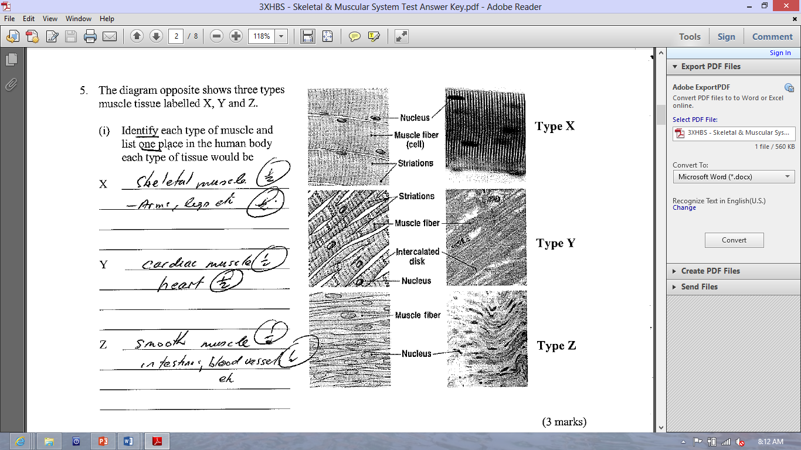

Identify each type of muscle tissue and list one place in the human body each type of tissue would be? [3 Marks]

1. Muscle X:

______________________________________________________________________________________________________________________________________________________

1. Muscle Y:

______________________________________________________________________________________________________________________________________________________

1. Muscle Z:

_____________________________________________________________________________________________________________________________________________________

1. The diagram shows Sally lifting weights from below her hips to a position directly above her head:



1. Name the term to best describe her arm movements as she raises her arms above her head?

[1 Mark]

_______________________________________________________________________________

1. Below is a diagram of someone raising their forearm towards their shoulder. Label the following terms on the diagram: [2 Marks]
   * 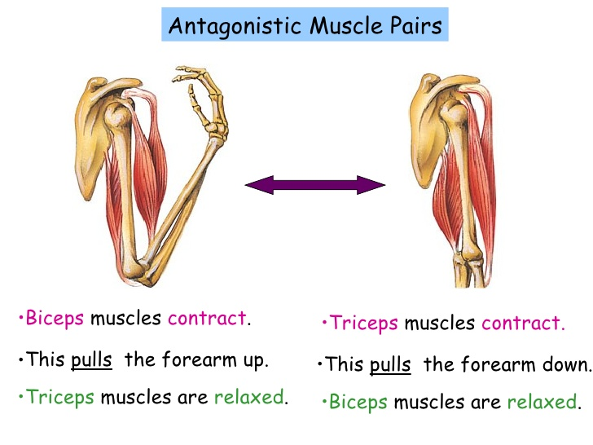*Agonist, belly, origin, insertion*
2. Explain, using the movement shown in the diagram above, what is meant by the statement that “skeletal muscles are arranged in antagonistic pairs with the support of synergist muscles”? [3 marks]

_______________________________________________________________________________________________________________________________________________________________________________________________________________________________________________________________________________________________________________________________________________________________________________________________________________________________________________________________________________________________________________________________________________________________________________________________________________________________________________________

1. Using examples, explain the difference between muscle endurance and muscle strength

[4 marks]

________________________________________________________________________________________________________________________________________________________________________________________________________________________________________________________________________________________________________________________________________________________________________________________________________________________________________________________________________________________________________________________________________________________________________________________________________________________________________________________________________________

1. Describe the difference between gross motor movements and fine motor movements.

[2 marks]

____________________________________________________________________________________________________________________________________________________________________________________________________________________________________________________________________________________________________________________________________________________________________________________________________________________________________________________________________________________________________________

1. Explain why it is important for a baby to learn how to crawl before they learn how to walk.

[3 Marks]

____________________________________________________________________________________________________________________________________________________________________________________________________________________________________________________________________________________________________________________________________________________________________________________________________________________________________________________________________________________________________________

1. Predict the impact of a low protein diet on the muscular system [3 Marks]

___________________________________________________________________________________________________________________________________________________________________________________________________________________________________________________________________________________________________________________________________________________________________________________________________________________________________________________________________________________________________________

***EXTENDED ANSWER [13 Marks]***

1. Explain why the body does not contract all muscle fibres at the same time when balancing or holding a position for an extended period of time? [2 Marks]

__________________________________________________________________________________________________________________________________________________________________________________________________________________________________________________________________________________________________________________________________________________________________________________________________________________________________________________________________________________________

1. 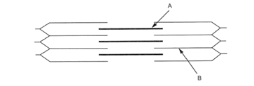Contraction of muscles can be seen at the microscopic level. The functional unit of a myofibril is called a sarcomere the diagram below shows the sliding filament theory identify the proteins labelled A and B in the diagram below. [2 Marks]
2. A: __________________________________________________
3. B: __________________________________________________
4. Explain how the muscular system and nervous system work together to bring about skeletal muscle contraction. Include what happens in a sarcomere. [3 Marks]

__________________________________________________________________________________________________________________________________________________________________________________________________________________________________________________________________________________________________________________________________________________________________________________________________________________________________________________________________________________________

1. When muscles fail, it can have disastrous effects on human health. Explain the cause, symptoms and treatment for two muscular dysfunctions. [6 Marks]

________________________________________________________________________________________________________________________________________________________________________________________________________________________________________________________________________________________________________________________________________________________________________________________________________________________________________________________________________________________________________________________________________________________________________________________________________________________________________________________________________________________________________________________________________________________________________________________________________________________________________________________________________________________________________________________________________________________________________________________________________________________